**Step 1: Access AWS Cost Explorer**

Log in to the AWS Management Console and select the Account name, then proceed to click on ‘Billing Dashboard’.

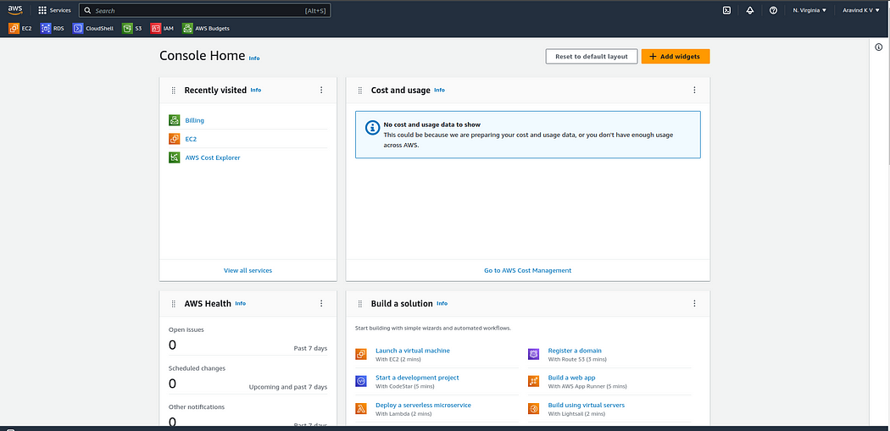

AWS Console

**Step 2:**

Navigate to the Billing section and scroll down to locate the Cost Management option. From there, select Budgets.

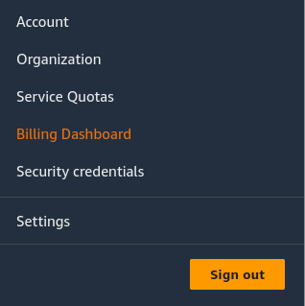

Billing Dashboard

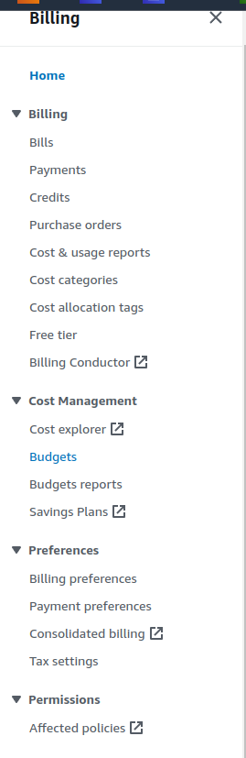

**Step 3:**

On the overview page, click on ‘Create Budget’.

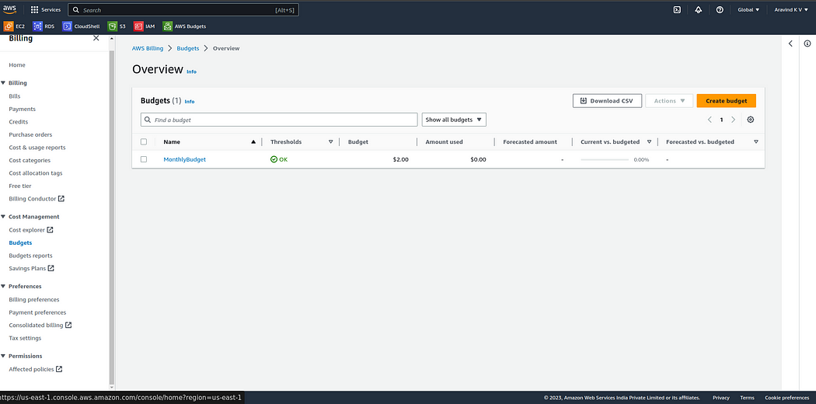

Create Budget

**Step 4:**

You have two choices for setting up a budget:

* Utilize a template
* Customize

For now, select ‘Use a template’ in the Budget setup.

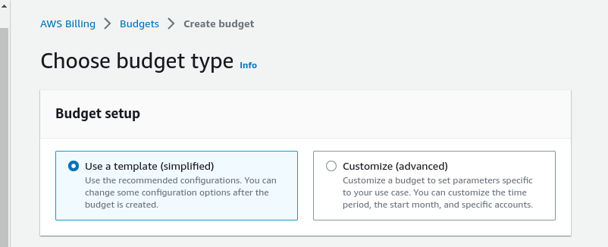

Select the Budget Setup

**Step 5:**

Within the Templates section, select the template that aligns with your needs. In this instance, I’m opting for the monthly cost budget template.

The zero-spend budget notifies you once you exceed $0.01.

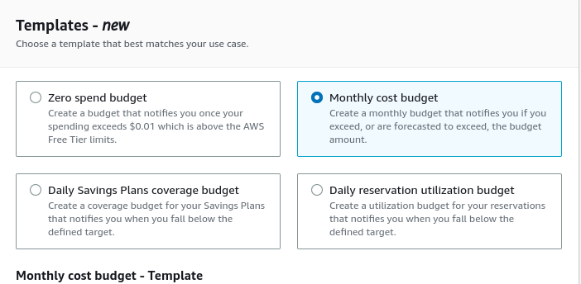

Templates

**Step 6:**

Next, assign a name to the Budget. Specify the budget amount in dollars. For example, I’ve set my Budget at $2.00 and enter the email addresses of the recipients you wish to notify when the amount is surpassed. In this scenario, I’m entering a dummy email address. You have the option to include multiple email addresses by separating them with commas.

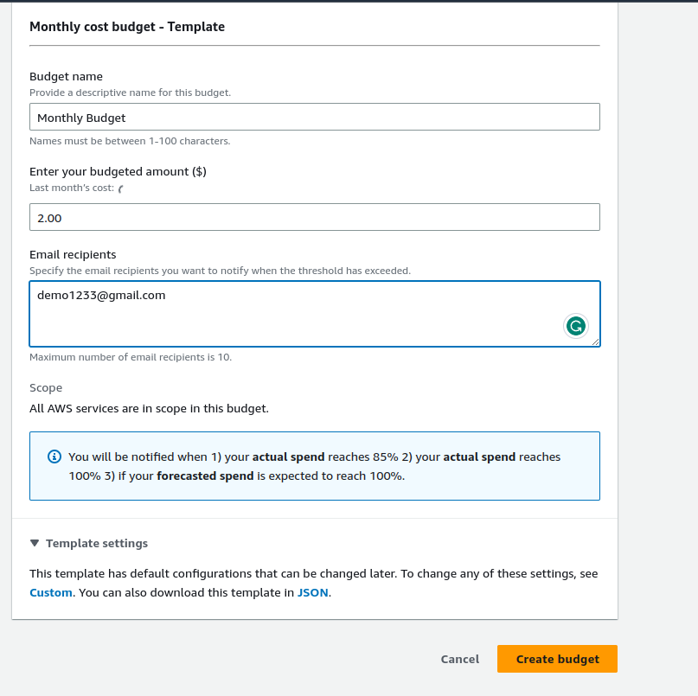

Monthly Cost Budget

Review the information you’ve entered, and proceed to click on the “Create budget” button.

**Step 7:**

Congratulations! Your budget has been successfully created. Click on the budget to explore its health status, details, history, and more. You have the option to edit and delete the budget.

